When Runtime, performance, memory, and power consumption are constraints, C++ is useful.

C++ Programs have 2 Parts.

Preprocessor directives (# symbol), and the main function.

When Including functions, using <iostream>, and “iostream” isn’t the same.

Using <> makes the program look in the current directory first, and then the directory where the standard libraries are kept.

Using “” means that the standard library directory is explored only if it isn’t found in the current directory. This will give different results depending on what is being included.

We can determine how many bytes of memory a certain variable type uses by using the sizeof() function.

Const is used to make variables constant, meaning their value won’t change for the life of the program.

Enum is also used to enumerate constants.



File IO

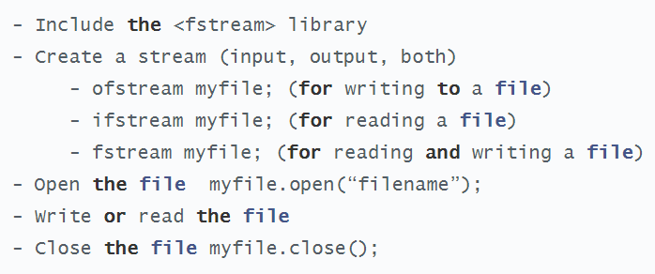

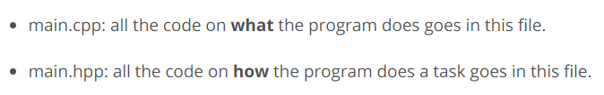

C++ GuideLines: <https://github.com/isocpp/CppCoreGuidelines>

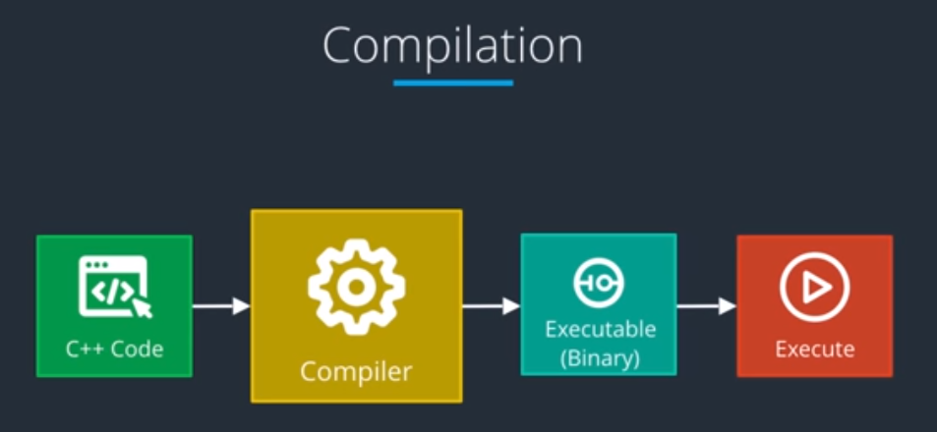

Scripting Languages use Just-In-Time Distribution.

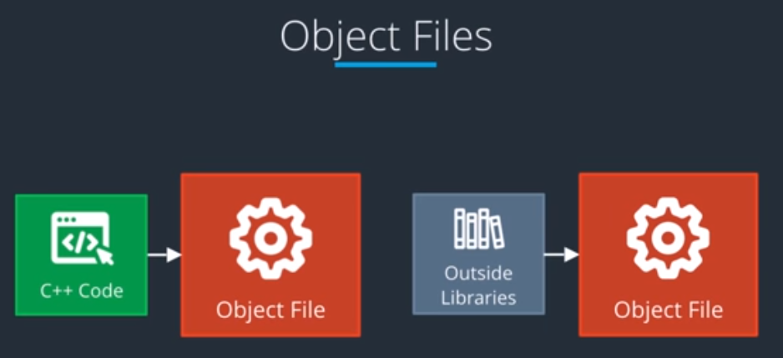

Linker Solves references to variables between the code and external libraries. Most Operating systems allow **dynamic linking**, where symbolic references point to libraries that are not compiled into the resulting library. The linking to libraries is then done during runtime.

